NSW eTendering – New Applications

Overview
This quick guide has been made available to assist new suppliers apply for Advertising and Digital Services via NSW eTendering. Only one user and email can be authorised as the company scheme owner (who registered on behalf of your organisation).

New Users - Registering an eTendering Account
Before you can lodge or submit an application, you must register an eTendering account with NSW eTendering. Click on Register on the right which will direct you to the buy.nsw Supplier Hub https://suppliers.buy.nsw.gov.au/login. Select “I’m a Supplier” and create a supplier account.

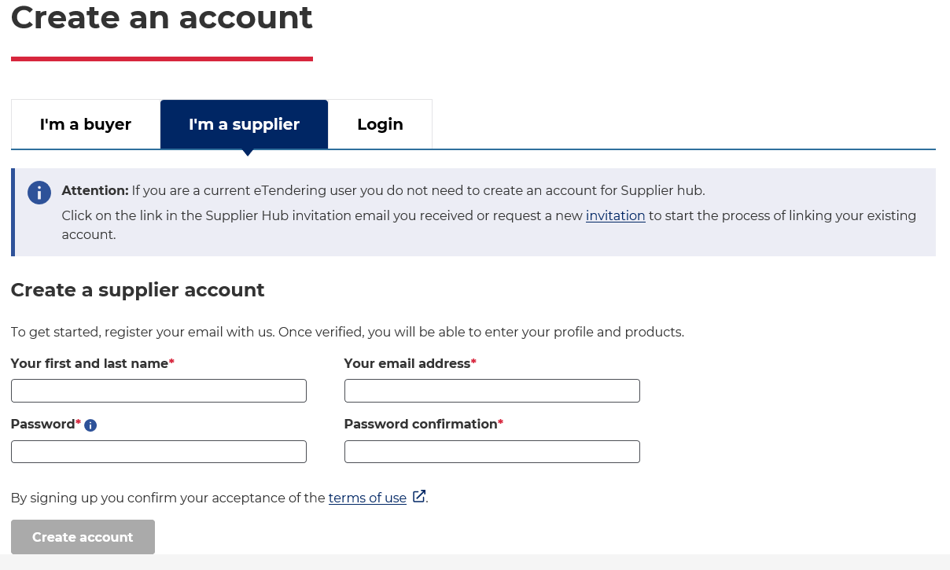

Once registration has been completed, navigate back to eTendering by selecting “Go to eTendering” to submit the application. After registration, and every time you login at NSW eTendering your name will be displayed at the corner of the page.

Existing Users – Log In
Login to the NSW eTendering website.

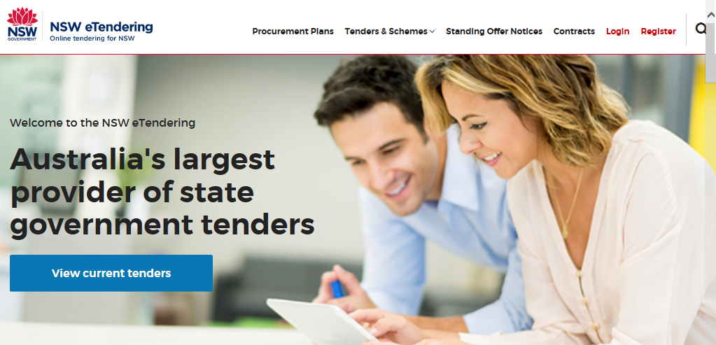

Search for the Scheme, using the magnifying glass icon and type, SCM2701.
Or, click on Tenders & Schemes, then Schemes, and scroll through the list to locate Advertising and Digital Services. Click on Full Details.

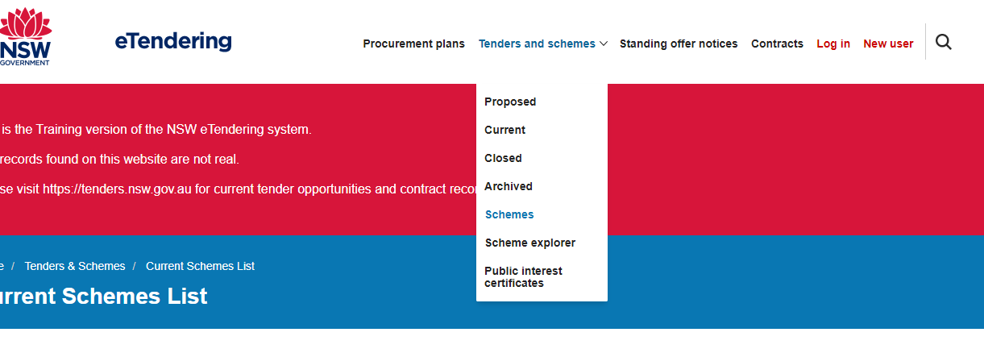

This will take you to the application page where you can view the scheme in greater detail, download the scheme terms and conditions, case studies and referee report templates and view the sample questionnaire.

It is recommended to complete your case studies and referee report templates before clicking on Start Application, however if you commence the application, you will be able to save it as a draft before submission. The scheme requires two (2) case studies, no older than 2 years, that support each nominated capability but no more than six (6) examples, and three (3) referee reports. At least two of your referees need to support the examples listed in the case studies template.

To commence, click on Start Application.

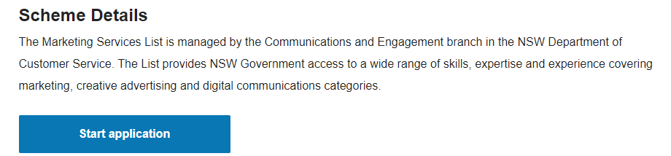

There are 6 steps that form the application process. Provide information on your company and click continue until you reach Step 4: Questionnaire.

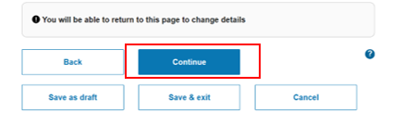
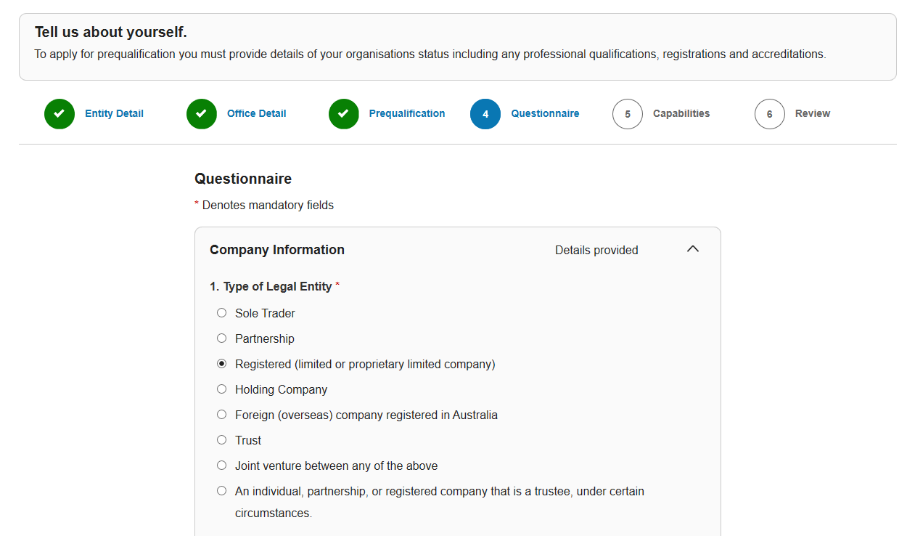

Click on the arrows to expand all the questions to ensure that a response has been provided for every section. Templates must be completed for case studies and referee reports. For multiple files, zip your documents as one folder and attach that as the response. Continue to move to the next step.

When you reach Step 5: Capabilities, you must nominate suitable capabilities to your application. These should support the examples in your case studies and referee reports. Vendors must not apply for more than three main capabilities, however, can nominate as many services under the main capabilities.

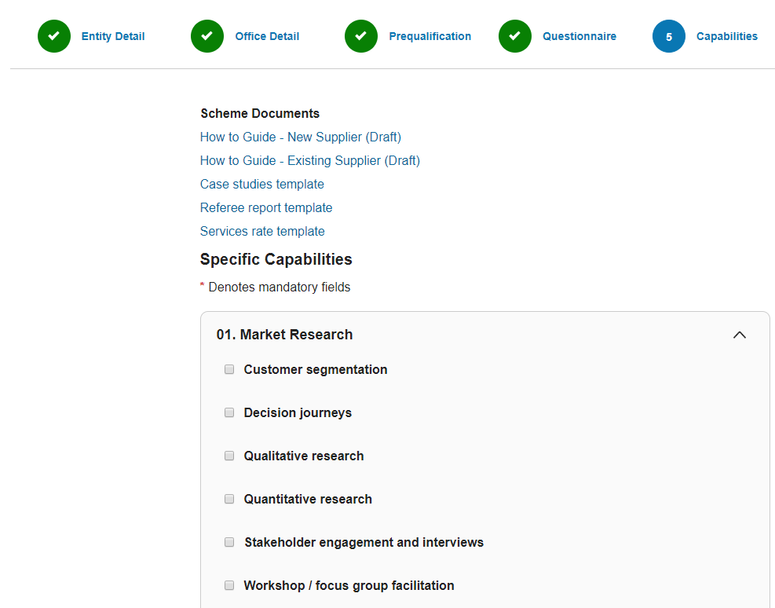

If you wish to apply for more than three main capabilities, please contact the team at advertising@customerservice.nsw.gov.au. Click the arrow to show/hide a list to reveal further information relating to each capability and service. Tick on the most appropriate. Click Continue to move forward.

At Step 6: Review Application, in agreement tick the checkbox I agree to the Scheme Terms & Conditions and then click Submit application.

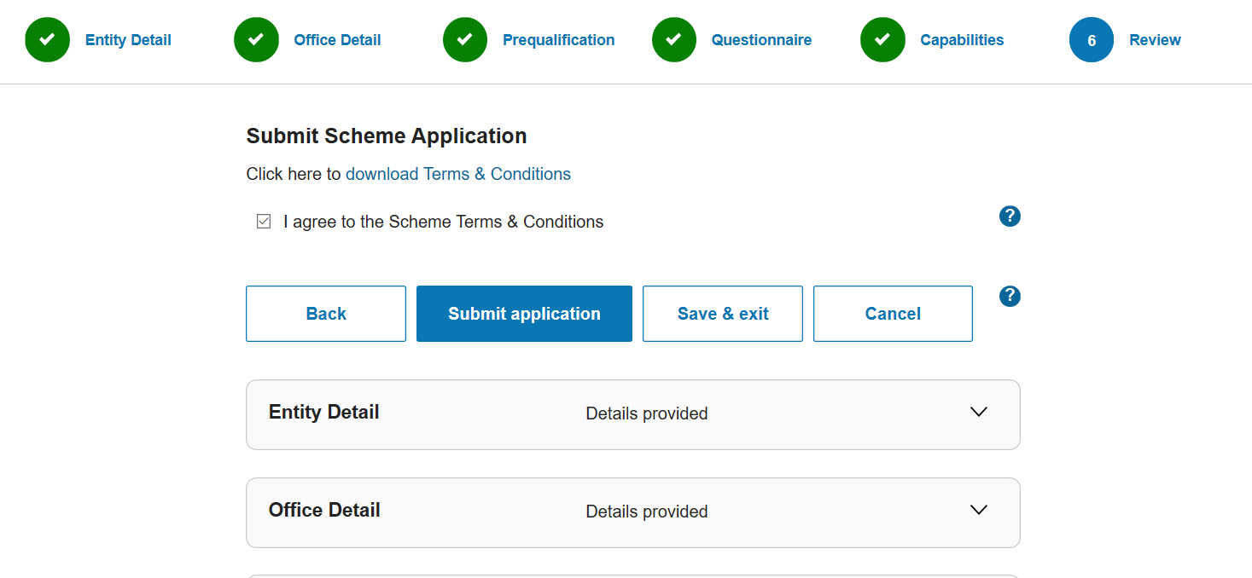

The modified application is submitted for review, you will receive a receipt number and will be notified via email once the application has been assessed.

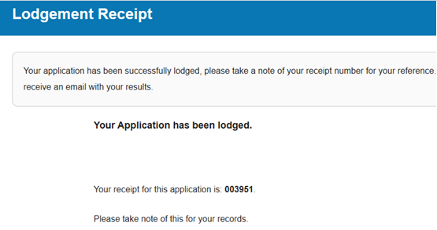

Options available to you whilst the application is under review are:

- View/Modify Application - You will be unable to modify the application if you have an application update already in review
- Withdraw Application Update - Any modified changes submitted will be discarded.

Draft Applications
After logging onto NSW eTendering, click on your name at the right, then Scheme Applications. A list of applications that you have commenced should appear. Locate the application for the Scheme and click on Edit Application.

Further Information
Further information is available via email from the NSWBuy Service Centre or on 1800 679 289.

https://tenders.nsw.gov.au/
https://tenders.nsw.gov.au/
mailto:nswbuy@treasury.nsw.gov.au

