1 Preparing Inspection and Test Plans
This Guideline is provided to assist service providers in preparing Inspection and Test Plans (ITPs) for construction contracts.
Although the current AS/NZS ISO 9001 Quality management systems – Requirements, does not cover ITP with inspection and testing, service providers will be required to develop and implement ITPs.

1.1 Purpose and scope
The purpose of an Inspection and Test Plan is to put together a single document that records all inspection and testing requirements relevant to a specific process. On a construction contract the process is likely to be a construction activity, element of work, trade work or providing a product section. An Inspection and Test Plan identifies the items of materials and work to be inspected or tested, by whom and at what stage or frequency, as well as Hold and Witness Points, references to relevant standards, acceptance criteria and the records to be maintained. Inspection and Test Plans, when properly implemented, help ensure that, and verify whether, work has been undertaken to the required standard and requirements, and that records are kept.

1.2 Glossary
Term | Definition
Hold point | A ‘hold’ point defines a point beyond which work may not proceed without the authorisation of a designated service provider or authority.  This ‘designated service provider or authority’ might be an agency's or other customer’s representative/authorised person, or a regulatory authority (such as a council, Sydney Water, WorkCover and the like) representative, or it may be the service provider inspecting its service provider or employee or agent.
Witness point | A ‘witness’ point provides a party (such as the customer, service provider and a regulatory authority) with the opportunity to witness the inspection or test or aspect of the work, at their discretion.
Surveillance | Surveillance - Intermittent monitoring of any stage of the work in progress (whether by the service provider or customer).
Self-inspection | Where the service provider performing the work verifies the quality progressively - often with the aid of checklists.
Work area | A discrete section of the whole work, usually defined by location, where any trade work or activity would be completed before it moves onto another area. Examples include a wall, a room, a building, a length of pipeline between manholes and the like. Also referred to as lots.

1.3 Roles and Responsibilities
There are no set rules as to who, in a service provider organisation, should document Inspection and Test Plans. It is appropriate, however, that they receive input from those with a good technical and practical knowledge of, and experience in, the activities involved. The use, understanding and acceptance of ITPs by inspectors and other personnel will generally be greatly enhanced if they are involved in their preparation.
The service provider is responsible for ensuring that all the required Inspection and Test Plans are prepared, including those covering work or processes to be carried out by its service providers. While it is preferable that its service providers prepare the ITPs for their own work, in the final analysis some may require the service provider’s involvement.
A senior representative of the service provider would be made responsible for approving Inspection and Test Plans, and any subsequent amendments, prior to their submission or submission of compliance/conformity certification to the customer. The contract conditions would define the submissions to the customer and any responses required.

1.4 Overview
The following steps are involved in documenting Inspection and Test Plans for a construction contract:
Step
Step 1 | Read the contract documents (including the technical specifications) and prepare a list of any discrepancies, ambiguities, missing information and standards of materials and/or workmanship that are considered inappropriate.
Step 2 | Contact the customer and resolve the issues listed as a result of Step 1.
Step 3 | Examine the scope of work and divide it into separate areas requiring an Inspection and Test Plan (where not already prescribed in the contract documents). As a general guide it is normally most convenient to document a separate Inspection and Test Plan for each trade or work area/section.
Step 4 | Note the Hold and Witness Points required by the customer (including as listed in the contract documents).
Step 5 | Review the contract documents again and note the requirements that have the most impact on the quality of the finished work. For each, ask the question ‘What will be the consequences if it is not made sure this is right?’ Be certain to include any references to tests, submitting information to the customer, obtaining approvals and Hold and Witness Points (see 1.6.9 for further information).
Step 6 | Determine from Step 5 which items or aspects of each inspection will need to be recorded on checklists and prepare these.
Step 7 | Discuss the checklists with those directly involved with the work and obtain their input. This input should particularly be directed at identifying those issues that have caused problems (and involved extra costs) in the past, and therefore warrant checking at the earliest opportunity to avoid unnecessary and costly rectification.
Step 8 | Prepare each Inspection and Test Plan to reflect the requirements of the contract documents. Reference the ITP in the Quality Management Plan and cross-reference to the other related ITPs.
Step 9 | Issue each Inspection and Test Plan and/or associated certification to the customer for consideration within a reasonable period prior to commencing the work described in the Plan and adjust them to suit any comment received (or act as otherwise required in the contract documents).
Step 10 | Decide how best to divide the whole of the work into work areas for control purposes and indicate these locations either on a schedule (with reference to grids and levels) or by marking up drawings.
Step 11 | Prepare and issue checklists for each work area and identify them according to location.
Step 12 | Train those directly involved with each of the ITP in their use. Formalise a procedure for the notification of Witness and Hold Points to the appropriate person(s).
Step 13 | Carry out inspections and tests in accordance with the Inspection and Test Plans, provide notices to the customer and/or regulatory authorities for Hold or Witness Points, as designated or applicable, and record the results on checklists.

1.5 Contract particulars
Record the following contract particulars on each of the Inspection and Test Plans:
- Contract Name
- Contract Number
- Description of process/activities for that particular Inspection and Test Plan

1.6 Inspection and Test Plans

1.6.1 General
1.6.2 to 1.6.9 inclusive describe what needs to be considered for each component of an Inspection and Test Plan. They explain the components and how to select the relevant information required for each.

1.6.2 Description of operation or stage of work requiring inspection or test
Because 100% inspection and testing in most cases is neither practical nor desirable, it is necessary to adopt a testing frequency and sampling process which provides a representative indication of the work to suit the risks involved, as is addressed in 1.6.4.
Inspections and tests are often best done after a number of separate activities, but prior to a major one that will cover up previous work. Service providers would carry out preliminary tests to assist in obtaining an early indication of conformity.
Determining the type and extent of inspections and tests (along with the characteristics - see 1.6.3) is probably the most challenging aspect of documenting an Inspection and Test Plan. The approvals required are sometimes easier to determine as they are usually specified and identify particular work/stages requiring inspections and tests. The type, timing and frequency of inspections and tests vary to suit the risks and work involved.
The ‘what to test’, ‘how to test’ and ‘when to test’ is governed by:
- What the work is and how complex it is
- Accessibility for inspections and sampling
- Consequences of failure, including as follows:
- Cost of remedial work
- Effect on construction program
- Accessibility for rectification
- Disruption to use of building or structure
- Consequential damage to other elements
- Threat to safety of workers and public
- Availability of resources.
The type, timing and frequency (the what, when and how often) of inspections and tests are best determined in conjunction with the consideration of the characteristics to be verified.

1.6.3 Characteristics of inspection/test/approval
The characteristics of a work item can be defined as ‘a distinguishable property of an item, material or process’. Examples of characteristics are colour, texture, size, strength, flatness, alignment, capacity and the like.
The characteristics to be verified will frequently determine the stage at which the inspection or test must take place if the potential for subsequent nonconformities is to be avoided. This further work might also cover up or deny access for the purposes of verifying certain characteristics.
Some characteristics can only be considered after one particular operation and before another, such as the inspection of steel reinforcement after installation but prior to the pouring of concrete.

1.6.4 Stage/frequency
The inspection/test stage/frequency will often be determined by the requirements of the contract documents or by the type of inspection and/or test and the characteristics under consideration, as outlined above. In the latter case however, there is the potential for a considerable range in what constitutes the most appropriate frequency and sampling process. It is suggested that a representative sampling of the work to suit the risks involved be used as a guide initially. Thereafter, frequencies would be increased and processes reviewed for ‘problem’ work activities and decreased where consistent conformity was evidenced.

1.6.5 Records
Records are essential to quality management because they provide the documented evidence necessary to verify that a product/service is in accordance with the contract requirements.
The records would be in various forms, and would include the checklists, test certificates, certificates of compliance/conformity, survey data, written approvals and the like. Inspection and Test Plans would help define the records required.

1.6.6 Specification/standard
The standards against which conformity is measured can take various forms. The most common source is usually the contract technical specification. Other standards would often be referenced in this document, and may include any of the following:
- Contract documents/specification generally
- Contract drawings
- Approved workshop drawings and/or calculations
- Approved technical details/procedures
- Approved samples and/or prototypes
- Regulatory requirements
- Australian Standards
- International Standards
- Standard specifications
- Manufacturers’ recommendations.

1.6.7 Acceptance criteria
Acceptance criteria would normally be defined in the contract documents (either directly or by reference to other standards such as Australian Standards). Where this is not the case it would be necessary to identify them and possibly to agree to them with the customer. It is preferable to establish acceptance criteria with the customer (where they are not specified or clear) to agree the yardsticks (such as test panels/sections or previous work) against which a product/service is to be declared conforming or nonconforming.

1.6.8 Inspection/test procedures
For many inspections/tests, the methods employed will be specified or self evident and determined by the characteristics being examined. In other cases, however, the precise manner in which the inspection/test is carried out would need to be identified and described. A clearly described test procedure will usually be necessary to help achieve consistent and reliable results.
A typical test procedure using statistical techniques might, for example, cover:
- reference to work areas/lots or batches
- frequency of sampling
- method of taking samples
- method of conducting a test (including conditions)
- qualifications of test personnel and equipment calibration/condition/specification
- method of documenting results
In some cases it may be possible to satisfy the requirements simply by referencing the requirements of Australian Standards and the like.

1.6.9 Hold and Witness Points
It is the service provider's responsibility to identify the Hold and Witness Points (with the people responsible for the inspection/test/endorsement and other requirements) that are required for its service providers and employees doing the work. The service provider would do this to the extent that is necessary to be confident that the work is being carried out to the standards required.
The customer usually retains the option to inspect the work at any stage and may identify Hold and Witness Points requiring the customer’s attendance. When preparing an ITP, the word ‘Surveillance’ would be shown against all selected inspection or test points that are not otherwise covered by Hold or Witness Points.

1.6.10 Checklists
As noted in 1.6.2, with some work, the logical stage to carry out an inspection or test is often after a number of separate activities, but prior to a major one that will cover up previous work.
It is often useful to complete checklists at such stages and with each inspection and test - where they will, in effect, summarise the procedures that have, and should have, taken place up to the particular point in the work process.
Checklists are useful reminders to the person doing the work of all the matters that are to be addressed. They are used to confirm all the matters have been attended to. They are also reminders to the person inspecting the work of all the matters that should be checked.
A checklist also gives an opportunity to record any special or unusual conditions under the contract, and draw these to the attention of the people doing the work. For example, special precautions for protecting existing work, notifications to the public, and other matters that might not normally be required for the particular trade or activity, may be included.
The fact that checklists exist, and that their use and content have been verified, would give a customer confidence that the person doing the work is aware of all the important steps, attributes and matters to be addressed, and the standards that should be complied with, and that conformity is being verified.

2 Inspection and Test Plan assessment checklist
The following typical checklist for Inspection and Test Plans has been designed to assist customers in assessing service providers’ ITPs. It may also assist service providers in developing their ITPs, as a guide to the content of ITPs. The customer may specify other items that would be addressed in the service providers’ ITPs to support the control of risks. The Clause references are to those in the current AS/NZS ISO 9001 Quality management systems – Requirements.
Please respond with Y = yes, N = no, O = not applicable

2.1 Planning of inspection and testing

4.2 Inspection and Test Plan
❑ Have ITPs been developed for all the relevant contract activities? (Clause 4.2)
❑ Are there ITPs for each activity affecting quality? (Clause 4.2)
❑ Are all the Plan documents identified and their revision status shown? (Clause 4.2.3)
❑ Are all the Plan records legible, readily identifiable and retrievable? (Clause 4.2.4)

5 Management responsibility
❑ Does the service provider identify and include all customer requirements in ITPs (Clause 5.2)?
❑ Is the contract quality representative nominated in the ITPs? (Clause 5.5.3)
❑ Do the ITPs nominate the person responsible on site for all key and related construction activities? (Clause 5.5.3)

6 Resource management
❑ Do the ITPs identify the resources proposed to carry out inspections and tests? (clause 6.1)
❑ Do the ITPs include the minimum required qualifications and experience of the people that are to carry out inspections and tests? (Clause 6.2)
❑ Do the ITPs identify the required equipment, facilities and supporting services? (Clause 6.3)
❑ Do the ITPs identify each critical working environment? (Clause 6.4)

7 Product realisation
❑ Are the ITPs updated to reflect changes to customer requirements? (Clause 7.2)
❑ Do the ITPs identify inspections and tests to verify/validate design? (Clause 7.3)
❑ Do the ITPs identify the inspections and tests required to ensure that the products/services meet the requirements? (Clause 7.4)
❑ Do the ITPs reflect the control of conditions required for inspection and testing? (Clause 7.5)
❑ Do the ITPs identify whether the monitoring and measuring equipment are calibrated and to specification? (Clause 7.6)

8 Measurement, analysis and improvement
❑ Does the service provider plan and implement in the ITPs the monitoring, measurement, and analysis needed to demonstrate conformity to product requirements of all work?
❑ Does the service provider state in the ITPs who is responsible for receiving, in-process and final inspection and testing for all work activities and for closing out work areas?
❑ Do the ITPs include the methods for indicating when nonconformity control is initiated and for closing out work areas?
❑ Have inspection and test forms been developed and implemented for recording inspection and testing for each activity? (each stage in a process may be on separate but linked forms)
Receiving inspection
❑ Do the ITPs define responsibility for verifying conformity of the supplied product to requirements before using it in the constructed works?
❑ Do the ITPs adequately address the inspection and testing requirements for the supplied product before it is used in the constructed works?
In-process inspection
❑ Do the ITPs define responsibility and provide for in-process inspection and testing?
❑ Do the ITPs adequately address the inspection and testing requirements for all the products/services during construction of the works?
Final Inspection and Testing
❑ Do the ITPs define responsibility and provide for final (or acceptance) inspection and testing?
❑ Does the service provider have a method and define responsibility in the ITPs for final review of all inspection/test results to confirm that all inspections and tests have been carried out to verify completely conformity to product requirements for each work area?
2.2 Inspection and test forms
Do the ITP forms indicate:
❑ all the inspection and testing required by the customer?
❑ inspections and tests to verify and validate design (where applicable)?
❑ inspection and tests required for the supplied product before it is used in the works?
❑ inspection and tests required for the products/services during construction of the works?
❑ who performs the inspection or test and at what stage of the contract work?
❑ how each inspection or test is to be carried out and recorded? (such as a documented testing procedure or by reference to a standard test method)
❑ the acceptance criteria and frequency of testing, including customer's requirements?
(reference to a contract specification clause alone may not be acceptable)
❑ the record reference verifying conformity of materials/product or preceding work to the requirements?
❑ who reviews inspection/test results, evaluates whether work conforms to the product requirements, determines what to do next if work does not pass a required inspection or test, and closes out completed and conforming work areas?
❑ when statistical analysis of test results is required?
❑ provision for confirmation that all inspections and tests have been carried out to verify completely conformity to product requirements in each work area?

Sample forms

Inspection and test plan
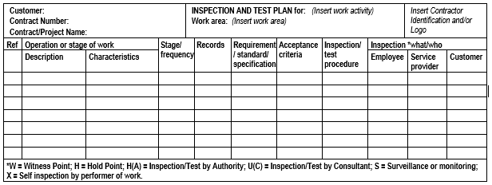

Checklist
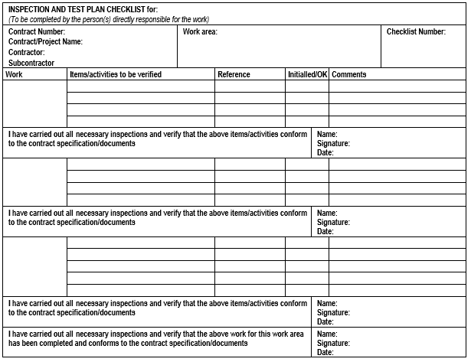

Examples

Inspection and test plans
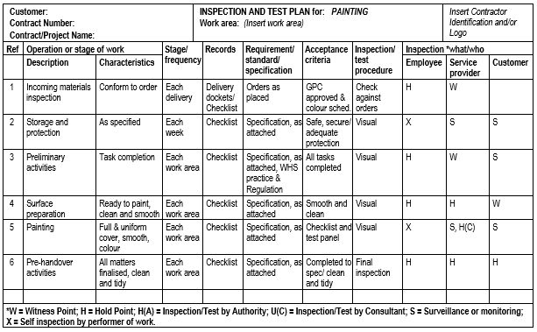
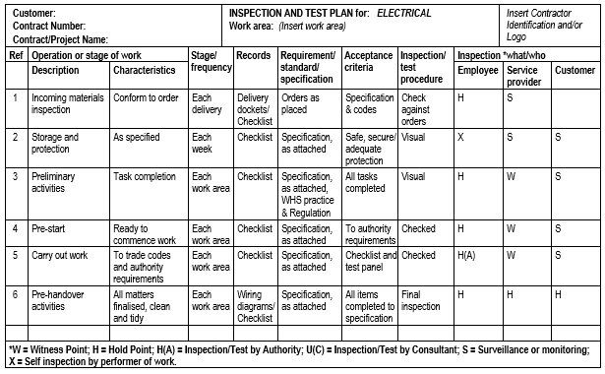

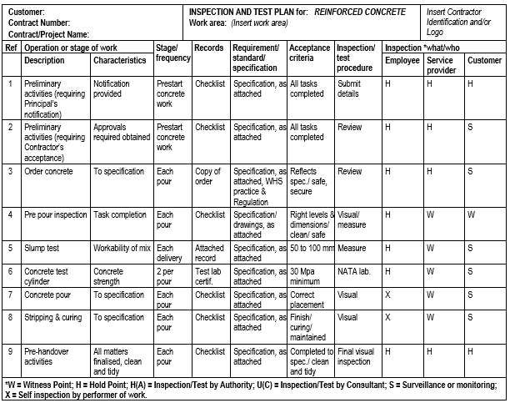

Checklist
