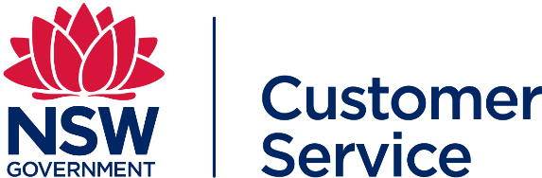
Customer Onboarding Checklist

Agency Details
Agency |  | Cluster
Contact Name

CHECKLIST
Completed | Action | Note
Become Informed
 | Obtained details and copy of agency’s existing telecommunications contract | Confirm your current contract information, any expiration dates, termination clauses, unit pricing, special services, existing discount structures, service volumes.
 | Read through the TPA information available on the buy.nsw website that details the contract information, products and services and benefits for customers. | You can contact NSW Procurement Customer Service or ICT/ Digital Sourcing for any questions or clarifications needed.
 | Complete the Pricing schedule request form TPA service catalogue request form to access to the Service  Catalogue and email to tpa@customerservice.nsw.gov.au The Catalogue contains Service Provider’s pricing and details of their service offering. | Application request will need to be authorised by agency representative for prior to access being granted and Non- Disclosure Agreement to be completed.
Choosing your engagement type
 | 1. Direct engagement with Service Provider in accordance with Procurement Board Direction 2019-02 https://arp.nsw.gov.au/pbd-2019-02telecommunications-procurement Purchase services at TPA pricing | This requires no RFQ, and can be directly organised with the Service Provider
 | 2. Initiate the RFQ Customer Contract Process | Choose your TPA eligible Service Providers and proceed with RFQ processes. Customer Contract template, and RFQ assessment tool is available on the TPA Service Catalogue.
 | 3. Collaborate with other Agencies going to RFQ and aggregate service volumes.  (Aggregated volumes may yield larger discounts) | Contact ICT/Digital Sourcing via email tpa@customerservice.nsw.gov.au for any questions or support to facilitate this option, or any other support required.
Engaging the Service Providers
 | For options 1 and 2 above, contact Service Provider and prepare for negotiations | This can be supported by ICT/Digital Sourcing
Contract Preparation, Approvals, Exemption and Sharing
 | Submit for PTS exemption (If applicable)  Approval process for new telecommunications services | buy.nsw | Relevant for contracts above $100,000 (TCV)
 | Prepare RFQ or Customer Contract for any additional services, terms and conditions not available in the TPA | Additional services/terms and conditions are agency specific
 | Send through executed Customer Contracts to DCS | Share Customer Contracts including but not limited to, the existence of that Customer Contract, the types, quantity and value of Services ordered, saving and benefit figures and the performance of the  Contract (if requested)

Agency Representative acknowledgment
 | Name | Signature | Date
Senior Manager

Version 3.1 1

