SCM1191 CONSULTANTS IN CONSTRUCTION SCHEME

Agency Guidelines
Construction-related consulting services valued below $9M

January 2024

Published by Department of Regional NSW
buy.nsw.gov.au
Title: Agency Guidelines
Subtitle: Construction-related consulting services valued below $9M
Department reference DOC21/28048
More information
Contact the NSW Procurement Service Centre
- Telephone: 1800 NSW BUY (1800 679 289)
- Email: nswbuy@treasury.nsw.gov.au
© State of New South Wales through Department of Regional NSW 2021. You may copy, distribute, display, download and otherwise freely deal with this publication for any purpose, provided that you attribute the Department of Regional NSW as the owner. However, you must obtain permission if you wish to charge others for access to the publication (other than at cost); include the publication in advertising or a product for sale; modify the publication; or republish the publication on a website. You may freely link to the publication on a departmental website.
Disclaimer: The information contained in this publication is based on knowledge and understanding at the time of writing and may not be accurate, current or complete. The State of New South Wales (including the Regional NSW), the author and the publisher take no responsibility, and will accept no liability, for the accuracy, currency, reliability or correctness of any information included in the document (including material provided by third parties). Readers should make their own inquiries and rely on their own advice when making decisions related to material contained in this publication.

What’s changed?
This prequalification scheme has been updated to make it easier for NSW Government agencies to fully understand the Scheme’s key features and its benefits when engaging prequalified suppliers.

From 1 August 2023, a new Infrastructure Advisory (IA) Services Contract Framework is recommended for use by Agencies
The IA contract framework is recommended for use by NSW Government agencies starting 1 August 2023. After this date, agencies are encouraged to use the IA contract framework for all new procurements of IA Services, inclusive of the following recommended Whole-of-Government schemes:
- Consultants in Construction up to $9M Scheme (SCM1191)
- Consultants in Construction above $9M Procurement List (SCM10611)
- Performance and Management Services Scheme engagement type 15 (SCM0005)
- Government Architect's Strategy and Design Scheme (SCM0801)
Please refer to the infrastructure advisory services category page on buy.nsw for more details and copies of the contract templates and tools.

From 1 November 2022, the newly established Infrastructure Advisory Standard Commercial Framework is recommended for use by Agencies as guidance for all engagement types in this Scheme
The Infrastructure Advisory Standard Commercial Framework (IA SCF) includes the following recommended commercial elements:
- Standardised resource and service types
- Capped daily resource rates
- Discount structure
- Expenses policy.

From 29 November 2020, NSW Government Agencies can no longer use Scheme SCM1191 for procurements above $9M ex GST as a result of the introduction of the Enforceable Procurement provisions (EPP) by the NSW Procurement Board.
To facilitate procurements above $9M ex GST, a separate Procurement List was established. Agencies are encouraged to use that Procurement List for procuring construction related consulting services above $9M.

Getting started

buy.nsw documents
SCM1191 Applicant Guidelines and associated documents for applicants and agencies are available in buy.nsw at consultants-in-construction-scheme.

Terms and Definitions
Refer to terms and definitions used in this document.

What is Supplier Hub?
Supplier Hub is the NSW Government's online procurement platform for connecting buyers and suppliers.
From 1 July 2023, Supplier Hub registration is mandatory for suppliers that want to actively sell to the NSW Government or respond to advertised government opportunities.

What Does Supplier Hub offer?
Supplier Hub provides:
- A general list of suppliers that have provided basic information, completing the initial self-registration process
- Lists of prequalified suppliers (to whole-of-government schemes) that can be invited for selective tenders/respond to an opportunity by a registered buyer against their capabilities
- Opportunities for suppliers registered on Supplier Hub (using the self-registration method) to sell to NSW Government
- A marketplace for buyers to identify registered supplier based on showcased products and services
- An opportunity for suppliers to share key information including case studies, price lists and product details

Why Register on Supplier Hub?
Only registered buyers can access lists of prequalified suppliers and view their profiles in full detail and the services offered.
On Supplier Hub, registered buyers can:
- Search all the self-registered suppliers
- View supplier profiles in detail, including prequalification schemes and Procurement List memberships
- Find a specialist supplier
- Find a supplier by geographical area
- Contact a supplier
- Identify the following categories of suppliers:
  - Verified Aboriginal-owned
  - Verified Disability employment organisation
  - Verified Gender-equitable
  - Australian owned
  - Not for Profit
  - Regional
  - Small Medium Enterprise (SME)
  - Start-Up

Buyer Registration to Supplier Hub
NSW Government employees, or eligible non-government buyers, can sign up as a buyer on Supplier Hub by providing their name, email address, and password.
For additional details, refer to the Buyer User Guide available on the buy.nsw Help and Support Page.

Enquiries
For general enquiries please contact consultant.prequal@pwa.nsw.gov.au or the NSW
Procurement Service Centre (details inside front cover).

For specific enquiries about the IA Services Commercial and Contract Frameworks, please contact infra-advisory@treasury.nsw.gov.au

Schedule of Document Amendments
Revision Number | Date | Update Description
2 | January 2024 | Revised text of sections 5 and 6 in relation to insurances, Business Management System certifications and licences
1 | October 2023 | - Updated details to descriptions of work categories  - Updated current Scheme expiry date.  - Added reference to new Board Direction PBD 2023-01 -Skills, training, and diversity in Construction.  - Added information about IA Services Standard framework.  - Added schedule of document amendments  - Corrected format for buy.nsw and NSW Public Works  - Added instructions for using the buy.nsw Supplier Hub system

Contents
Contents vii
1 Scheme SCM1191 1
1.1 Benefits of the Scheme 2
1.2 Supplier Hub Registration vs. Prequalification 2
1.3 Accreditation for Construction Procurement 2
2 Buyer Access to Supplier Hub 3
2.1 Register a buyer account on Supplier Hub 3
2.2 Accessing the Supplier List 4
2.3 Accessing Supplier Information Online 5
3 Procurement Planning 9
3.1 Estimating the Value of a Procurement 9
4 Work Categories 4
4.1 Architectural 4
4.2 Assessment 6
4.3 Engineering 8
4.4 Management 10
4.5 Planning 11
4.6 Security Consultants & Security Equipment Specialist 12
5 Scheme Information 12
5.1 List of Prequalified Suppliers 12
5.2 Eligibility criteria 12
5.2.1 Legal Capacity 12
5.2.2 Financial Capacity 12
5.2.3 Commercial Ability 12
5.2.4 Technical Ability 12
6 Inviting Submissions from Suppliers 14
6.1 Market Approaches Guide 14
6.2 Tendering Rules 14
6.3 IA Commercial and Contract Frameworks 14
6.4 Trusts and Trustees 14
6.5 Insurances 15
6.6 Business Management System certifications and Licences 15
7 Supplier Performance 16
7.1 Monitoring of Supplier Performance 16
7.2 Supplier Suspension and Removal from Scheme 16
8 Review and Development of the Scheme 18
9 NSW Procurement Policy Framework 19
9.1 Procurement Board Directions 19
9.2 Enforceable Procurement Provisions (EPP) 19
9.3 NSW Government Action Plan: A ten point commitment to the construction sector 19
9.4 NSW Government Supplier Code of Conduct 19
9.5 Financial Assessment 20
9.6 Small and Medium Enterprise (SME) 20
9.7 Aboriginal Procurement Policy (APP) 20
9.8 Skills and Training in Construction 20
9.9 Modern Slavery Legislation 21
9.10 Disability organisations 21
10 IA Services Commercial and Contract Frameworks 22
Attachment A Terms and definitions 24

1 Scheme SCM1191
These guidelines are for Agencies procuring construction related consulting services valued below $9M (ex GST). This document should be read in conjunction with the Scheme Conditions.
The following table provides a summary of the key features of the Scheme:
Item | Description
Scope of the Scheme | Construction related consulting services valued below $9M ex GST
Work Categories: | Primary work categories include 39 sub-categories to select when applying for prequalification. Some of the work categories require mandatory licences, qualifications, certifications, and accreditations.  The primary categories for Scheme SCM1191 prequalification are:  - Architectural  - Assessment  - Engineering  - Planning  - Management  - Security Consultants & Security Equipment Specialists
Financial Thresholds | Two tiers of prequalification exist under this Scheme:  - Registered Consultants — Engagements up to $250,000 ex GST  - Certified Consultants — Engagements over $250,000 but below $9M ex GST.  - Services above $9M: refer to Procurement List for Consultants in Construction SCM10611
Compliance with provisions of the EPP | No  Procurements from this Scheme fall below the Enforceable Procurement Provisions (EPP) threshold for construction works.
Application deadline | None.  The Scheme is always open for Applications
Duration of the Scheme | 31 December 2025
Minimum number of quotes to be sought from Suppliers | - Up to $50K ex GST: One Quote  - $50K and above: Three Quotes.  The above recommended minimum number of Suppliers to be invited does not override any approved procurement governance requirements by an Agency.  Quote rules can also vary if you are dealing (for instance) with Aboriginal-owned businesses, or SMEs (particularly in regional areas). Agencies should check the relevant policies for allowable variances from the quote rules.

1.1 Benefits of the Scheme
The key benefits for Agencies using this Scheme include:
- Easy identification of Suppliers to be included in tenders for construction related consulting engagements. This reduces the time, cost, and risk to agencies.
- A centralised prequalification assessment based on objective criteria to appoint suitable Suppliers to the Scheme
- Sharing of performance related information and volume allocation to Suppliers across the NSW Government
- Provides guidance on commercials (recommended capped daily rates, discount structures and capped expenses) and contractual arrangements (standard forms of contract) following the establishment of the IA Services Frameworks.

1.2 Supplier Hub Registration vs. Prequalification
Registration on the buy.nsw Supplier Hub portal (using the self-registration process) is not equivalent to the Legal Entity prequalification/membership to the Scheme.
Scheme membership/prequalification is only granted once the online application has been lodged and approved by the Scheme Owner. Prequalification does not extend to related or subsidiary companies or entities of a prequalified supplier.
Applications lodged using business names are not considered valid for scheme membership/prequalification and will be rejected.

Accreditation for Construction Procurement
The Accreditation Program for Construction Procurement addresses the specific capabilities and risks of procuring construction works and services. Accredited agencies have greater autonomy to procure construction services than unaccredited agencies.
A summary of the program is available on the buy.nsw website at https://info.buy.nsw.gov.au/buyer-guidance/get-started/accreditation/construction-accreditation
- The assurance process focuses on all 3 phases of the procurement process, as defined in the NSW Procurement Policy Framework (plan, source and manage), and applies to:
- Unaccredited agencies engaging in construction procurement above $1.3M (ex. GST)
- Construction procurement accredited agencies that have been engaged to provide assurance for unaccredited agencies.All construction projects with an estimated total cost of $10M and above must be registered with Infrastructure NSW and comply with the Infrastructure Investor Assurance Framework.

2 Buyer Access to Supplier Hub
NSW Government buyers must be registered on buy.nsw Supplier Hub to access the prequalified supplier’s information. Registered buyers can review full details of self-identified and prequalified suppliers.

2.1 Register a buyer account on Supplier Hub
To register as a buyer an email address which has a government domain is required. Go to https://buy.nsw.gov.au/login/signup and sign up from the login tab.

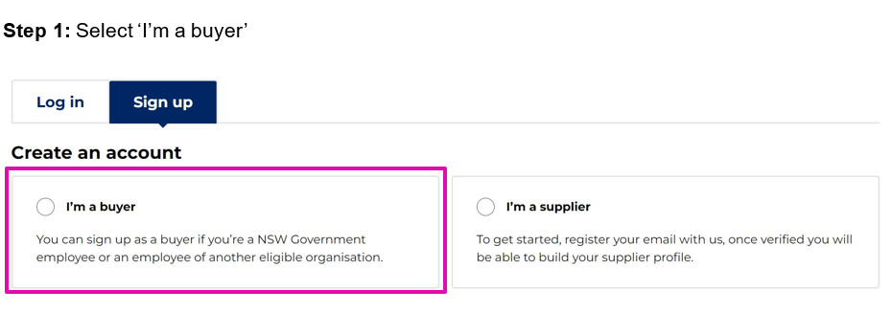

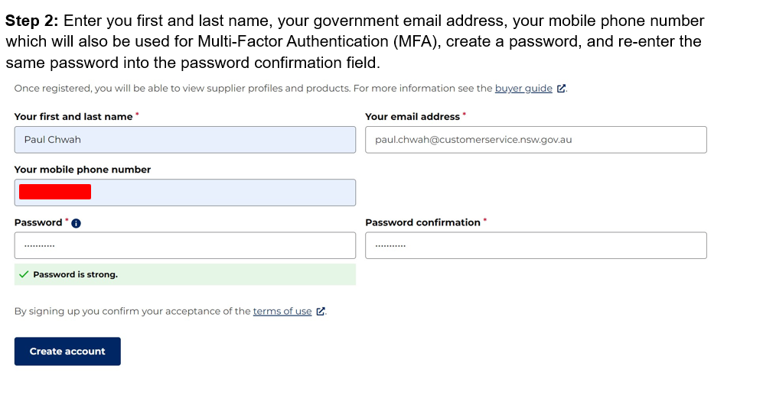
NOTE: Passwords must be at least 11 characters long and contain a capital letter, a symbol and a number.

2.2 Accessing the Supplier List
Once logged in, the buyer dashboard will show the overview bar, recent activity, and a range of buy.nsw apps will appear as shown below:
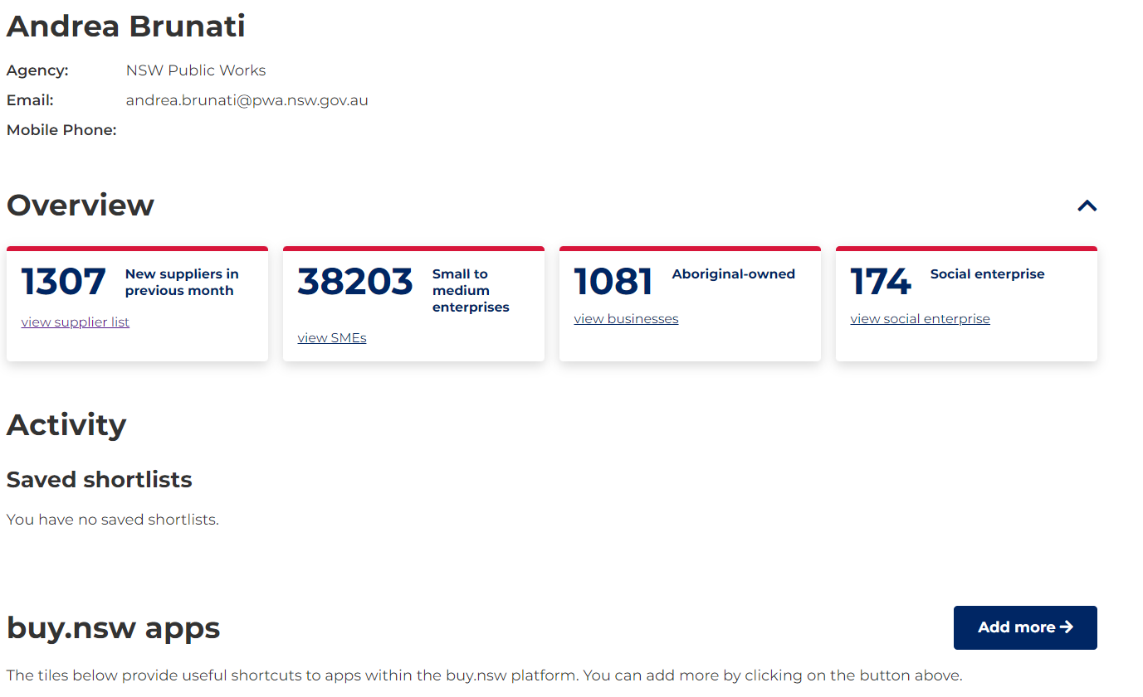

STEP 1: Scroll down to the “Scheme lists” tile and click on it
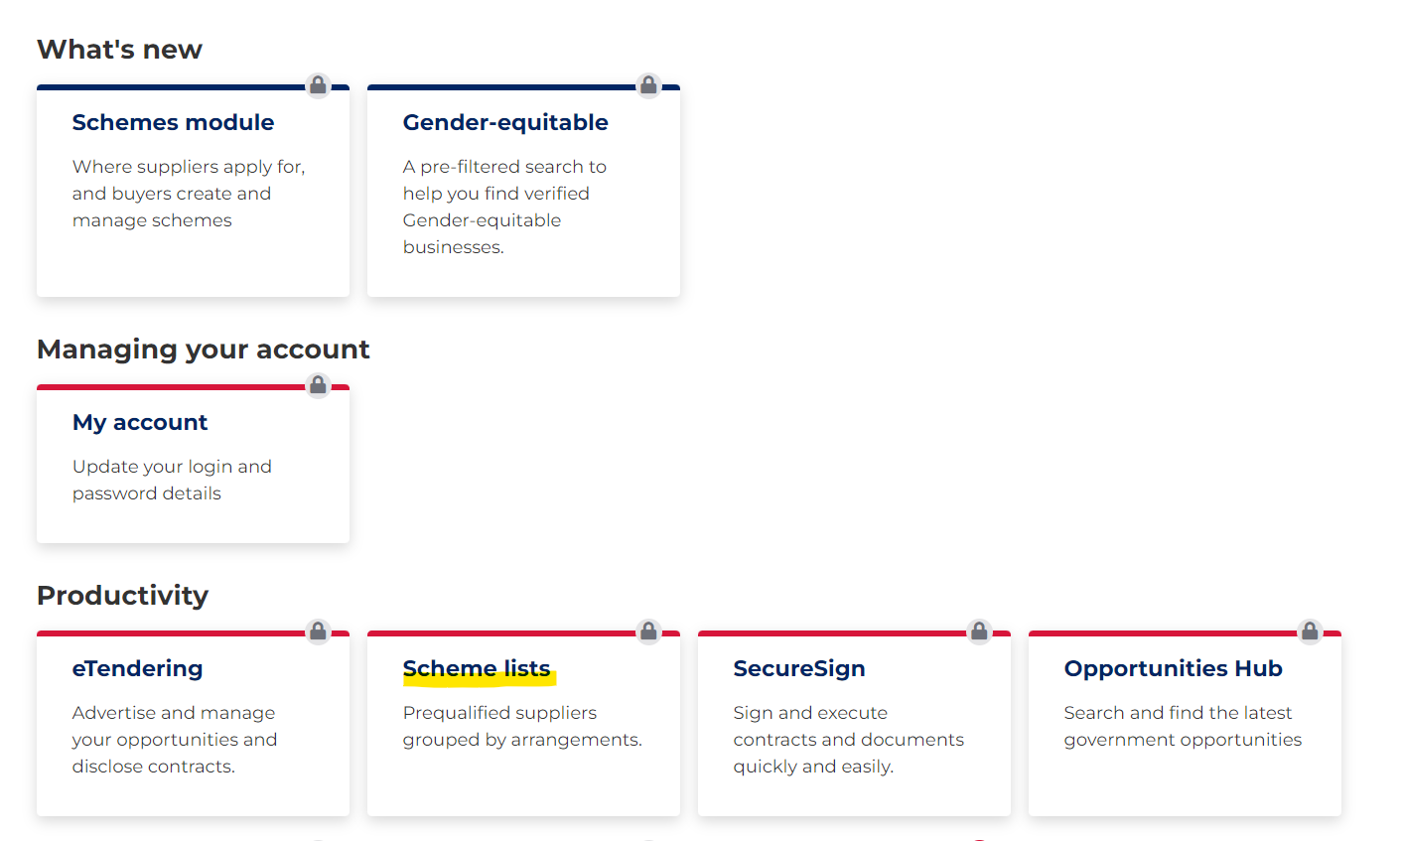
STEP 2: Scroll down the page and click the ‘Download members CSV’ file
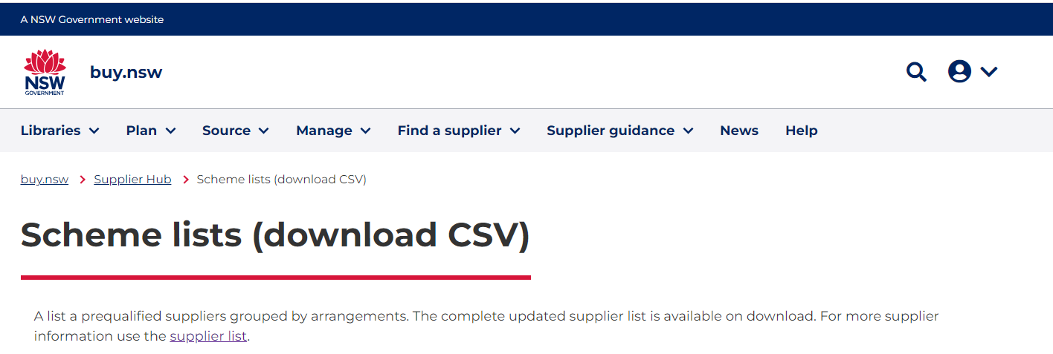
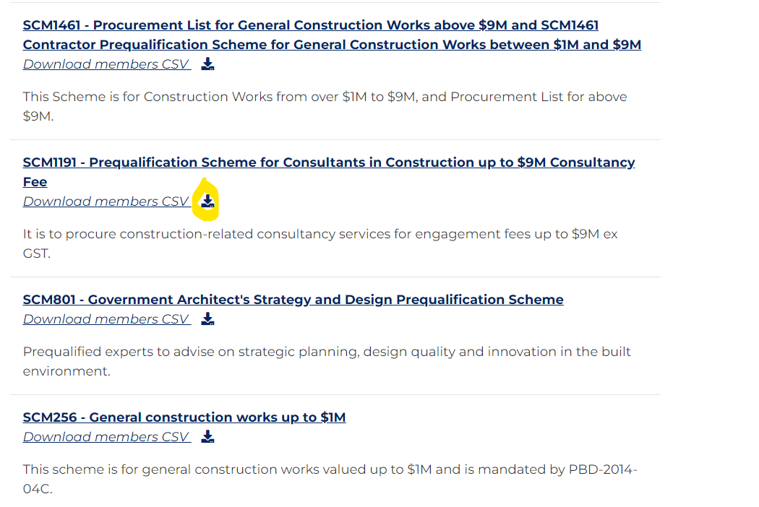
STEP 3: Once the file has been downloaded, save the excel file containing the list of prequalified suppliers and filter as required.

2.3 Accessing Supplier Information Online
Once on https://buy.nsw.gov.au/, access the buyer account, and click on the “Find a supplier” tile as shown on the example screenshot below:
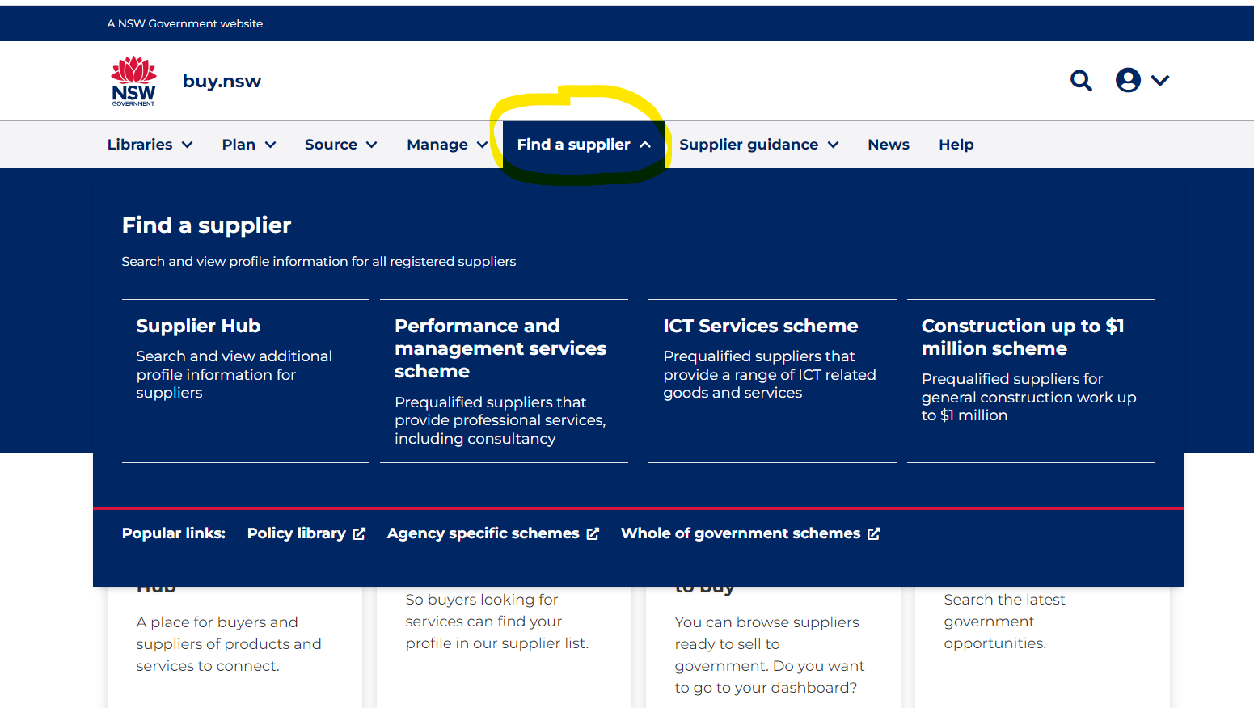
STEP 1: Move to the “Refine search” left column
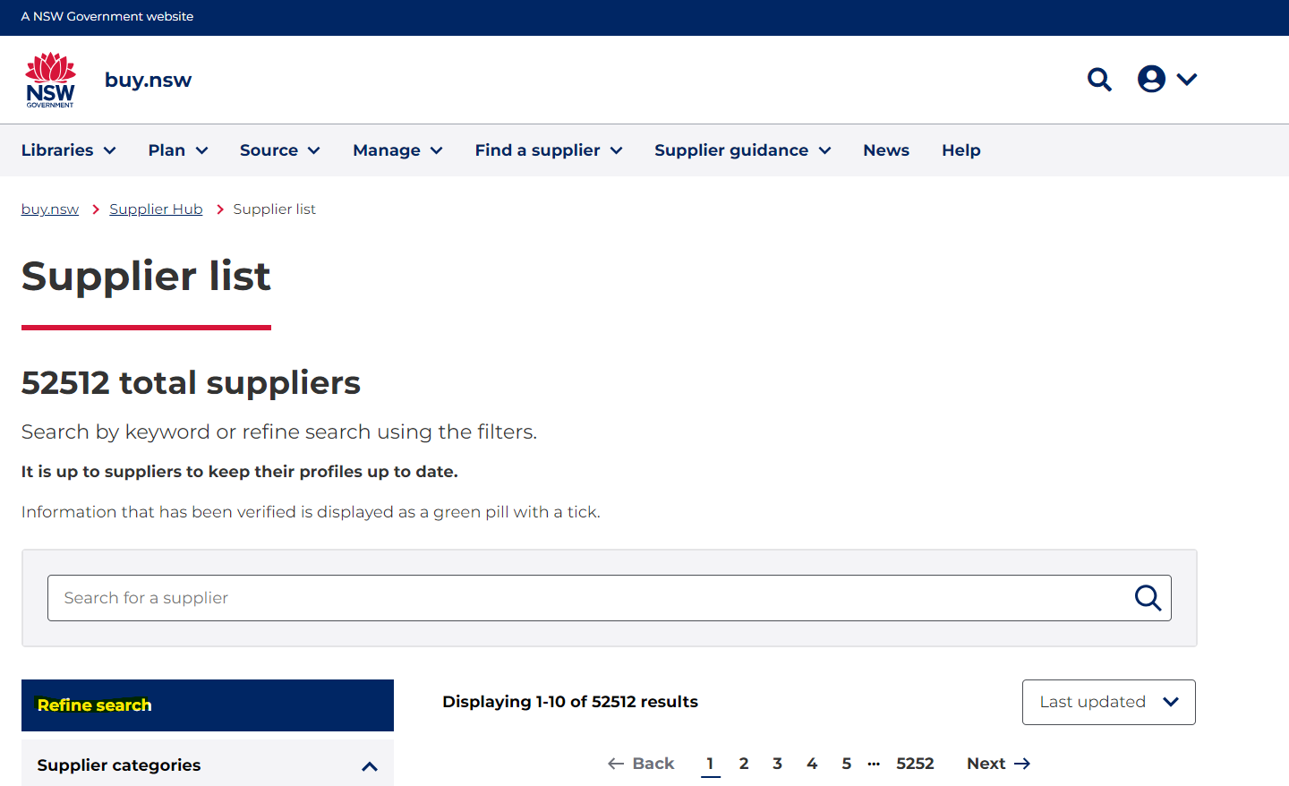

STEP 2: Expand the ‘Supplier categories” filter and tick the “Construction” box as shown below:

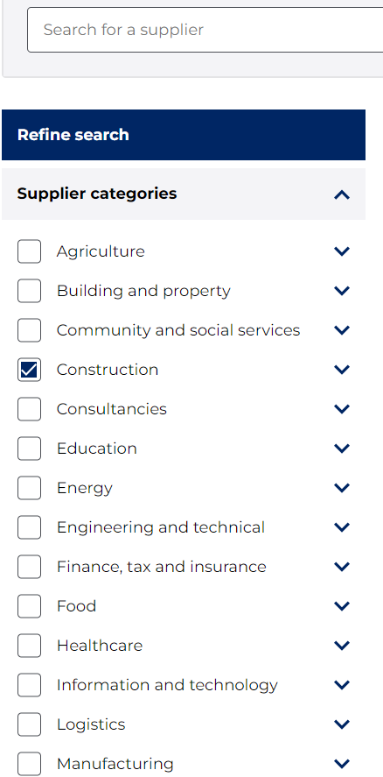

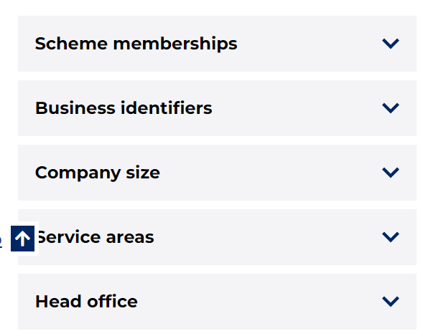

STEP 3: Scroll down to the “Scheme memberships” filter and tick the “SCM1191” box as shown below:
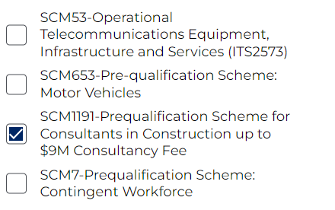

STEP 4: Scroll down to the “Service areas” filter, expand and tick the required area box as below:

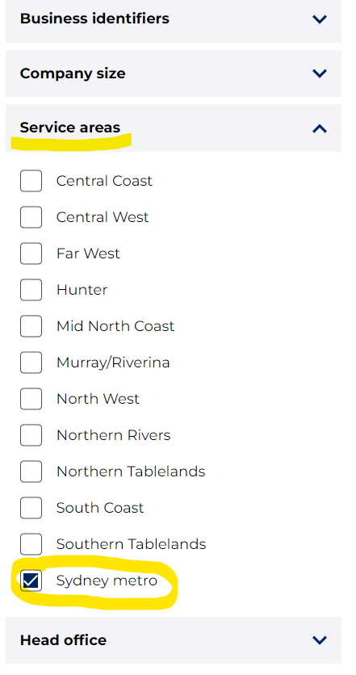

3 Procurement Planning

3.1 Estimating the Value of a Procurement
This Scheme is relevant to NSW Procurement’s Plan-Source-Manage approach to procurement. It assists Agencies in the planning phase to identify Suppliers who are suitability qualified to tender for construction related consultancy work below $9M.
Please note that the source and manage phases of procurement are outside of the scope of the Scheme.
- Agencies using this Scheme are encouraged to develop their own sourcing strategies in accordance with the NSW Procurement Policy Framework.
Agencies need to assess the estimated value of their procurement to correctly determine if they can use Scheme SCM1191 for procuring construction related consultancies. This is further relevant when determining if Registered Consultants or Certified Consultants should be approached for submissions.
The estimated value of a procurement is an estimate of the maximum value (ex GST) of the proposed procurement contract made by the Agency, including:
- the value of the goods or services to be procured,
- all forms of remuneration payable by the government Agency, including any premiums, fees, commissions, interest and other revenue streams that may be provided for in the proposed contract,
- any options, extensions, renewals or other mechanisms that may be executed over the life of the contract.
If a procurement is to be conducted in multiple parts with a number of proposed procurement contracts awarded either at the same time or over a period of time, with one or more Suppliers, the estimated value of the procurement must include the estimated value of all of the proposed procurement contracts.
A procurement must not be divided into separate parts if a purpose of the division is to avoid a relevant procurement threshold.
If the maximum value of a proposed procurement cannot be estimated, the procurement is taken to have an estimated value that exceeds the relevant Procurement Board Direction PBD-2019-05 Enforceable Procurement Provisions (EPP) procurement thresholds.
In this case, Agencies must either approach the open market or use the Consultants in Construction Procurement List instead of SCM1191.
Agencies are to note that the threshold for a procurement of construction services is $9.584M. This Scheme can be used for procurements up to $9M. The lower threshold of $9M has been chosen as it is easier to communicate to Agencies and Suppliers and allows for adjustments to the EPP threshold which may occur in the future.
.

4 Work Categories

4.1 Architectural
Category | Category Reference | Summary description
Architectural – General | 201 | Provision of services in the planning and documentation of new and refurbished facilities including the preparation of design briefs, development of master plans, facility planning, user consultation, concept and schematic designs, detailed designs, and construction contract documentation.  Architecture – General areas of practice include provision of consultancy/professional services for construction-related projects/capital works of office buildings, fit out and refurbishment, residences, industrial and commercial offices, court houses, police stations.
Architecture – Health | 203 | Provision of services in the planning and documentation of new and refurbished facilities including the preparation of design briefs, development of master plans, facility planning, user consultation, concept and schematic designs, detailed designs, and construction contract documentation.  Architecture – Health areas of practice include provision of consultancy/professional services for construction-related projects/capital works of allied health care services such as podiatry, speech pathology, dietetics, psychology and social work, nursing homes.
Architecture Planning and Delivery – Health Infrastructure | 220 | Provision of services in the planning and documentation of new and refurbished facilities including the preparation of design briefs, development of master plans, facility planning, user consultation, concept and schematic designs, detailed designs, and construction contract documentation.  Architecture – Health Infrastructure areas of practice include provision of consultancy/professional services for construction-related projects/capital works of health infrastructure services
Architecture – Education Primary and Secondary | 202 | Provision of services in the planning and documentation of new and refurbished facilities including the preparation of design briefs, development of master plans, facility planning, user consultation, concept and schematic designs, detailed designs, and construction contract documentation  Architecture – Education Primary and Secondary areas of practice include provision of consultancy/professional services for construction-related projects/capital works of primary and secondary education facilities.
Architecture – Education Tertiary | 200 | Provision of services in the planning and documentation of new and refurbished facilities including the preparation of design briefs, development of master plans, facility planning, user consultation, concept and schematic designs, detailed designs, and construction contract documentation  Architecture – Education Tertiary areas of practice include provision of consultancy/professional services for construction-related projects/capital works of tertiary education facilities.
Architecture – Correctional | 204 | Provision of services in the planning and documentation of new and refurbished facilities including the preparation of design briefs, development of master plans, facility planning, user consultation, concept and schematic designs, detailed designs, and construction contract documentation  Architecture – Correctional areas of practice include provision of consultancy/professional services for construction-related projects/capital works of correctional facilities.
Architecture – Heritage | 219 | Provision of services in the planning and documentation of new and refurbished facilities including the preparation of design briefs, development of master plans, facility planning, user consultation, concept and schematic designs, detailed designs, and construction contract documentation  Architecture – Heritage areas of practice include provision of consultancy/professional services for construction-related projects/capital works of heritage-related work to office buildings, fit out and refurbishment, residences, industrial and commercial offices and non-specialist areas.

4.2 Assessment
Category | Category Reference | Summary description
Environmental Impact Assessment | 400 | Preparation of preliminary environmental investigation reports, environmental constraints mapping and analysis.  Preparation of reviews of environmental factors (REFs), statements of environmental effects (SEEs) or summary environmental reports (SERs) for projects unlikely to have a significant environmental impact.  Preparation of environmental impact statements in accordance with Secretary’s Environmental Assessment Requirements and response to submissions reports (for designated development or other projects likely to have a significant environmental impact)
Biodiversity/Ecological assessment | 401 | For assessments under the Biodiversity Assessment Method – a consistent method for the assessment of biodiversity values from a proposed development (including major projects), activity, clearing or biodiversity certification, as well as improvements in biodiversity values from management actions undertaken at a stewardship site. Provide guidance on how a proponent can avoid and minimise potential biodiversity impacts, and the number and class of biodiversity credits that need to be offset to achieve a standard of ‘no net loss’ of biodiversity.
Occupational Hygienists | 402 | Measure worker exposures, assess worker risks and develop controls to improve the workplace environment. Provide advice on control strategies including hazard elimination, engineering modifications, administrative controls and finally personal protective equipment.
Consulting Arborist | 403 | Advisory services for tree management, including preparation of Arboriculture Reports suitable for public exhibition for rezoning proposals, undertaking arboriculture surveys (including identification of quality and condition of existing vegetation, retention value assessments, identification of tree protection zones), contribution to strategic planning documentation to be submitted to the council, supporting the urban designers, statutory planners and other consultants.
Bushfire Modelling | 404 | Specialised in providing advice covering fire safety requirements in bushfire zones, including bushfire planning services and the completion of bushfire assessment reports for specific properties, considering the relevant council information, studies, development control plans and other relevant policies/guidelines
Aboriginal Cultural Heritage | 405 | Comprehensive services for Aboriginal cultural heritage, for example specialist investigations, archaeological excavations, stakeholder liaison and consultation, preparation of significance assessments and conservation and management recommendations, production of high-quality reports including archaeological analysis.
Dispute Managers | 337 | Management of resolution of disputes arising from contracts between NSW government agencies and service providers under the NSW Government Procurement System for Construction.
Independent Safety Assessor | 406 | Changes to the Transport Network that are considered to have a 'safety significant' impact require an independent third-party judgement on the validity and suitability of the safety assurance program supporting the change and ultimately the safety argument for the change.

4.3 Engineering
Category | Work type code | Summary description
Civil Engineering | 118 | Design and documentation of civil structures such as bridges, dams, retaining walls, reservoirs, car parks and roads.  The consultancy requirements of this category are relevant to but not limited by the listed subcategories: Wastewater Treatment, Recycling, Pumping and Pipework, Water Treatment, Recycling, Pumping and Pipework, Flooding, Water Storage, Storm water engineering services and Water resources services.
Electrical - Building | 115 | Design and documentation of requirements for indoor and outdoor lighting, power, HV/LV reticulation and switchboards, control, uninterruptable power supplies, generators, fire detection and voice and data cabling for site services, architectural facilities and buildings.
Mechanical – Building | 116 | Design and documentation of requirements for air conditioning, heating, ventilation, domestic hot water, non-potable water, cool rooms, steam, medical/industrial gases, building management and control systems for architectural facilities and buildings for civil works.
Structural Engineering | 119 | Design and documentation of the structural components of buildings, such as footings, beams, floors, roof structure walls, columns and roadworks, hydraulic & stormwater designs associated with buildings.
Fire Safety Engineering | 130 | Fire safety engineering and fire safety maintenance services and related advice. Includes advising on system requirements to comply with BCA, providing alternative building solutions, providing advice on maintenance of systems.
Fire Services – Sprinklers | 117 | Design and documentation of requirements for sprinkler systems. Does not include fire hydrants and hose reels, see Category 111 - Hydraulic.
Geotechnical Engineering | 109 | Investigation and report on ground conditions, natural behaviour, response to artificially changed conditions and capacity to support civil and architectural structures.  Specialist areas: engineering geology, hydrogeology, soil mechanics, and rock mechanics.
Facade | 131 | Design, analysis, inspection, auditing, remedial diagnostics, waterproofing, material analysis for the façade and cladding used on existing and new buildings
Acoustic Engineers | 132 | Identify the main noise and vibration generating sources and activities at all stages of construction (including demolition), and any noise sources during operation. Outline measures to minimise and mitigate the potential noise impacts to the surrounding area.
Hydraulic – including Town Gas, LPG and Fire Services | 111 | Design and documentation of hydraulic services within buildings and as site services to buildings, incl. water, sewerage, drainage, stormwater, town gas, LPG and fire hydrants and hose reels.
Traffic & Transport Engineering | 124 | Advice, design and documentation related to traffic flow on and around sites.
Electrical and Electronics Engineering | 133 | Design, develop, install, manage and maintain equipment, plant and systems within the electrical, electronic, communication and computer systems areas, being applied to electrical power generation, transmission, distribution and utilisation, manufacture, instrumentation and control in industry, communications networks, electronic plant and equipment, integration and control of computer systems.  Further includes design and improvement of telecommunications systems, hardware and software, systems for media broadcasting and sound, and sophisticated electronics.

4.4 Management
Category | Category Reference | Summary description
Project Director | 335 | Leads and directs all phases of construction from business case development to post-occupancy completion for high-value and high-risk projects.  The Project Director leverages leadership skills and advanced project management skills for the effective planning and delivery of projects to achieve stated benefits realisation objectives.
Project Management | 313 | Project Management of services to support planning, design, town planning and approval process for capital works and management of construction activities during the delivery, including project management of planning by the head contractor following award of the construction contract and contract administration.  Includes all project management functions for the effective planning and delivery of projects to achieve stated benefit realisation objectives.
Project Manager Planning and Delivery – Health Infrastructure | 336 | Project Management of services to support planning, design, town planning and approval process for Health-related capital works and management of construction activities during the delivery, including project management of planning by the head contractor following award of the construction contract and contract administration

4.5 Planning
Category | Category Reference | Summary description
Value Management Facilitators | 328 | Value Management Analysis, including value for money analysis, workshop facilitation and report preparation.
Town Planning | 208 | Specialist advice, design and documentation related to the urban environment to ensure the orderly development of communities.  This category incorporates the shaping of cities, towns and regions by managing development, infrastructure and services. The consultancy requirements of this category are relevant to but not limited by the listed sub-categories: urban planning, master planning services, social and community-based planning services, rezoning services, regional and rural planning services, development assessment, strategic land use services, statutory land use services, transport planning services.
Quantity Surveying | 301 | Cost planning and estimating services, including cashflows, cost management, cost forecasting of contract documentation.
Compliance and Certification | 216 | Specialist advice with respect to building regulations Assess building plans to ensure that they comply with the Building Code of Australia (BCA), the Australian Standards referenced within it and any other relevant Building Acts or other legislation or requirements of the jurisdiction the building is in.  Registered certifiers assess and determine applications for development certificates for building and subdivision work. They are regulated by Fair Trading (in accordance with the Building & Development Certifier Act). Most certifiers are qualified building surveyors who can issue development certificates for building work, be appointed as the principal certifier, and carry out inspections.
Land Surveying | 225 | Measurement and mapping of the surrounding environment.  Included subcategories: Resource surveying, engineering surveying and cadastral surveying
Property Assessment Surveys and Detailed Property Assessment Surveys | 226 | Property Assessment Surveys inspect Residential Properties (dwelling or unit) to assess the conditions of various building components within the property including identifying any defects.  Detailed Property Assessment Surveys inspect high risks building elements which are associated with the whole of the building complex, including structural, hydraulic, electrical, roof inspection, trees, lifts
BCA and Access Consultants | 227 | Offer building regulations consulting expert advice and derive alternative building solutions, including to ensure Building Code of Australia (BCA) related compliance and proper accessibility for people with a disability

4.6 Security Consultants & Security Equipment Specialist
Category | Category Reference | Summary description
Security Consultants & Security Equipment Specialist | 500 | This category covers security activity as allowed under class 2A and 2B licence. Detailed description is provided in the Security Industry Act 1997.  It may also include design, documentation, site inspection, training and commissioning of electronic security systems for Correctional Centres, Court Houses, Police Stations and Juvenile Justice Centres. Special Selection Criteria and Site Conditions apply.  Specialist Areas: Electronic Perimeter Security Systems, Closed Circuit Television (CCTV), Video Conferencing, Guard Tour System, Cell Call System – includes Pass Door Intercom, Access Control Systems, Intruder Alarm Systems, Duress Systems, Public Address System, MATV System, Radio System, Biometrics, X-Ray Screening System, Walk Through Metal Detectors, PABX System, Voice System (Telephones), Data System (Computers), Cabling, Conduits and Pits, Lightning Protection, Uninterrupted Power Supply (UPS), Graphical User Interface (GUI)  Applicants must comply with NSW Security Licensing requirements in accordance with Security Industry Act 1997, where applicable. Applicant organisations need to have in place a Master License as well as individual Operative licenses for their personnel.

5 Scheme Information

5.1 List of Prequalified Suppliers
Registered buyers can view a current list of Suppliers included on the Scheme through their Supplier Hub account at https://buy.nsw.gov.au/login.

5.2 Eligibility criteria
Applications for this Scheme are assessed on four eligibility criteria:
- Legal Capacity
- Financial Capacity
- Commercial Ability
- Technical Ability
Approved prequalified suppliers have demonstrated achievement across all the above criteria against which applications are assessed.

Legal Capacity
Suppliers must have the legal capacity to enter into contracts with the NSW Government, and their legal entity registered for an ABN under the Australian Business/ASIC Register. Prequalified suppliers have also agreed to the NSW Supplier Code of Conduct.

5.2.2 Financial Capacity
Suppliers declared that they have the financial capacity to deliver contracts for the NSW Government. However, upon Application to be included on the Scheme, Applicant’s financial viability has not been validated by the NSW Government. Agencies procuring off the Scheme are advised to undertake their own due diligence to ensure that the Supplier indeed does have the required financial viability to undertake the works.

5.2.3 Commercial Ability
Refer to Appendix B of the Scheme Conditions to confirm for which Work Categories prequalified Suppliers have demonstrated that:
- Nominated Key personnel have been trained in cooperative based contracting, conflict resolution and alternative dispute resolution (when required)
- Appropriate Business Management System certifications, including Quality Management System (QMS), Workplace Health and Safety (WHS) systems are in place (when required)
- Suppliers are not required to provide evidence of insurance at the time of prequalification. However, Agencies must ask for a proof of public liability, workers compensation and professional indemnity insurance (as required)
- Agencies apply their own due diligence at the tendering stage ensuring that suppliers have valid insurances and Business Management Systems certifications in place

5.2.4 Technical Ability
- Applicants must demonstrate that they can meet all the four eligibility criteria depending on the Work Category for which they have applied to be included on the Scheme.
- Appendix B of the Scheme SCM1191 Conditions sets out the requirements for each Work Category. Examples of work category/capability requirements include:
- Numbers of years of organisational relevant and demonstrated experience
- Relevant experience (5 years)
- Relevant and independently recognized qualifications of nominated key personnel
- Registration and membership of nominated key personnel with a relevant professional body (when required)

6 Inviting Submissions from Suppliers

6.1 Market Approaches Guide
Refer to the Market Approaches Guide on buy.nsw for approaching the Supplier market.

6.2 Tendering Rules
Agencies can invite prequalified Suppliers on the Scheme when the selective tender method is chosen.
It is recommended that, as a minimum, Agencies will seek:
- Up to $50K ex GST: One Quote
- $50K and above: Three Quotes.
Agencies should invite Suppliers to submissions based on those Suppliers’:
- Nominated Work Category
- Relevant experience
- Financial capacity to undertake the proposed work
- Availability and capacity for undertaking the proposed work
- Suppliers’ compliance to the IA Services Frameworks (exception process for non-compliant suppliers)
The key principle of obtaining value for money in the procurement must be addressed by the procuring officer in all cases.
Unaccredited Agencies are reminded that they must comply with the assurance process for construction procurements valued over $1.3M.
The above minimum number of Suppliers to be invited does not override any approved procurement governance requirements of an Agency. Agencies should check their relevant policies for allowable variances from the competition level mentioned above.

6.3 IA Commercial and Contract Frameworks
Agencies are recommended to use the IA commercial and contract frameworks when procuring under this Scheme. Using standard contracting documents reduces risk to NSW Government Agencies and reduces the administrative burden for Suppliers. Please refer to the infrastructure advisory services category page on buy.nsw for more details and copies of the frameworks

6.4 Trusts and Trustees
A trust in itself is not a legal entity and is always controlled by a trustee. Only the trustee can sign a contract on behalf of the trust. Trustees as administrators for a particular trust can be prequalified in this scheme, if they meet the application requirements and are authorised to enter into a contract on behalf of the trust. (Trusts are not eligible as they can only contract via a trustee).
Agencies are advised to apply their own due diligence and, if necessary, seek legal and commercial advice during the tendering process when engaging an entity which is a Trust Structure.
Agencies should ensure the contract correctly describes the trustee as entering the contract in its capacity as trustee of the Trust, rather than it its own capacity. This means making sure the ABN of the Trust is quoted (not the trustee’s ABN). For example, ABC Pty Ltd (ACN 123 456 789) as trustee of the Jones Family Trust (ABN 9 876 654 321).

6.5 Insurances
For this Scheme, suppliers are not required to provide evidence of insurance at the time of prequalification. However, Agencies must ask for a proof of public liability, workers compensation and/or professional indemnity insurance (as required) at the tendering and contract award stages.
Agencies must ensure procurement documents:
- Define the minimum insurance levels that apply to the contract so that small (and medium) businesses can confirm they are able to secure the relevant insurances and are able to price their submissions appropriately
- State that it is a condition of contract award that the successful supplier provide a certificate of insurance or appropriate evidence they have minimum insurances in place, and that this evidence must be provided before the contract is executed
The following insurance provisions apply to construction procurement, including subcontracting arrangements:
- Ensure the minimum possible levels of public liability and professional indemnity insurance are imposed on small (and medium) businesses
- Allocate risk to the party best placed to mitigate or manage it, which may or may not be the supplier

6.6 Business Management System certifications and Licences
Prequalification for this Scheme requires suppliers to provide copies of current certifications for Business Management Systems (e.g., ISO 9001, ISO 45001) when lodging their application.
Agencies are advised to apply their own due diligence at the tendering stage ensuring that suppliers have valid/current Business Management Systems certifications in place.

For Security Consultants & Security Equipment Specialist (500) service category, a valid licence from NSW Police is mandatory at prequalification stage. Agencies are required to check that this licence is current at tendering stage.

7 Supplier Performance

7.1 Monitoring of Supplier Performance
Suppliers included on the Scheme are subject to a process of continuous monitoring and review in all matters related to the Scheme including the Supplier’s performance and project outcomes.
Agencies are encouraged to support PW, which is the Agency responsible for the Scheme, in administering the Scheme by monitoring the performance of the Suppliers.
Specifically, this includes the development of Consultants Performance Reports (CPR) and their regular provision to PW.
Agencies are further encouraged to monitor the following items and report any findings to NSWPW:
- Project outcomes of projects delivered by the Supplier
- Client satisfaction on projects delivered by the Supplier
- Consultant Performance Reports (CPR)
- Project Manager Performance Reports
- Project Director Performance Reports

Commercial Compliance
- Suppliers on the Scheme who have accepted the IA Services Commercial Framework, will be monitored for commercial compliance by the whole of government category team within NSW Procurement (NSWP). However, if agency buyers identify non-compliance, NSWP should be notified.

7.2 Supplier Suspension and Removal from Scheme
The NSW Government may suspend a Supplier from the Scheme for any non-compliance with the Scheme Conditions. Reasons for suspension specifically include that the NSW Government has reasonable belief regarding any of the following:
- That the Supplier has acted in contravention to the NSW Supplier Code of Conduct
- That the Supplier did not submit financial viability information or required reporting
- That the Supplier experienced an adverse change in capacity or capability
- Failure to obey an adjudicator’s determination under Building and Construction Industry Security of Payment Regulation 2020 (NSW), subject to other legal rights
- That the Supplier is bankrupt or insolvent
- That the Supplier has made one or more false declarations
- That there has been a significant deficiency or persistent deficiencies in the performance by the Supplier of any substantive requirement or obligation under a prior contract
- The Independent Commission Against Corruption (or an equivalent body in a jurisdiction in Australia), within the previous 10 years, has made a finding or has been of the opinion that the Supplier has engaged in corrupt conduct.
- In the above, a reference to Supplier includes, if the Supplier is a body corporate, a director and any other person involved in the management of the affairs of the body corporate.
- If a Supplier was suspended from the Scheme and the reason for the suspension cannot be resolved to the satisfaction of the NSW Government within 90 days the Supplier will be removed from the Scheme.

8 Review and Development of the Scheme
PW provides a small, dedicated team to administer the Scheme and assist agencies and Suppliers with enquiries and feedback for continuous improvement. Please contact consultant.prequal@pwa.nsw.gov.au

9 NSW Procurement Policy Framework
This section provides context about the applicable legislative and policy framework within which the Scheme operates.
Agencies must at all times comply with all relevant laws and policies, including but not limited to those listed in this section. A Supplier’s breach of any relevant policies and/or laws may result in suspension or removal from the Scheme.
The NSW Procurement Policy Framework provides a consolidated view of government procurement objectives and the Procurement Board’s requirements as they apply to each step of the procurement process.

9.1 Procurement Board Directions
From time to time the NSW Procurement Board issues Directions under the Public Works and Procurement Act 1912. These Directions determine the rules and guidelines around public sector procurement within the NSW Government. A library of all current Directions in force can be found on the buy.nsw website.

9.2 Enforceable Procurement Provisions (EPP)
Procurement Board Direction PBD-2019-05 Enforceable Procurement Provisions (EPP Direction) establishes legal requirements for NSW Government agencies arising from international procurement agreements. This includes how Government must engage with its Supplier market in a way that is fair, open and transparent to all Suppliers, including international Suppliers.

9.3 NSW Government Action Plan: A ten point commitment to the construction sector
The NSW Government recognises that it can only achieve its infrastructure objectives in partnership with the private sector, and that this depends on healthy ongoing competition between a capable field of construction firms, sub-contractors and the industry supply chain – not just now, but for years to come.
The NSW Government aims to be a “best in class” client for the construction industry and its Suppliers. In return, it expects industry to meet the highest standards of integrity, quality, innovation, diversity and inclusiveness.
In 2018 it issued A ten point commitment to the construction sector to achieve these goals.

9.4 NSW Government Supplier Code of Conduct
The NSW Government strives to conduct sustainable and inclusive government procurement.
Our Suppliers are our partners in delivering the best social and commercial outcomes for the state of NSW and its citizens.
The NSW Government requires all Suppliers to comply with relevant standards of behaviour and must report findings of dishonest, unfair, unconscionable, corrupt or illegal conduct to the NSW Procurement Board. These requirements are essential to business confidence in the NSW Government’s procurement regime as well as public trust more broadly in the Government’s decision-making processes.
A minimum set of expectations and behaviours for doing business with NSW Government has been articulated in the Supplier Code of Conduct. All Applicants and Suppliers to this Scheme must comply with it and must have a satisfactory record of compliance with the Code. This also includes ensuring that Suppliers and their subcontractors, consultants, and contractors comply with their legal obligations regarding their employees.
Applicants and Suppliers must further comply with the NSW Industrial Relations Guidelines: Building and Construction.

9.5 Financial Assessment
Financial assessments are part of the due diligence process in awarding NSW Government contracts. They are used to check the financial capacity of the Supplier to complete works or supply goods. Financial assessments are further undertaken during a contract to identify and assess any changes in the financial position and risks associated with the solvency of the contractor.
The Agency responsible for this Scheme may use financial assessments during the Application process. The NSW Government may engage a service provider prequalified under the Financial Services Prequalification Scheme SCM2491 to undertake such assessments.

9.6 Small and Medium Enterprise (SME)
The NSW Government is seeking to strengthen its construction supply chain. This will provide greater opportunities for SMEs and local businesses in regional NSW.
The Scheme Application process will identify small and medium businesses with the appropriate capability and capacity to participate in construction projects. Applicants are expected to select only those regions that their current capacity and capability can support.
For further information refer to the Procurement Board Direction PBD2019-03 on Buy.NSW

9.7 Aboriginal Procurement Policy (APP)
This Scheme is aligned to the principles of NSW Government’s Growing NSW’s First Economy framework. The framework is a key element of Opportunity, Choice, Healing, Responsibility and Empowerment (OCHRE).
The APP policy recognises that industry has a key role to play in broadening opportunities for Aboriginal people and that the NSW Government can use its relationship with business to deliver positive social outcomes.
APP has been developed to create opportunities for Aboriginal owned businesses and encourage Aboriginal employment and training through the supply chain of NSW Government contracts. The Scheme Application process will ask applicants if they are an Aboriginal business, as defined by the Aboriginal Procurement Policy framework.

9.8 Skills and Training in Construction
The NSW Government has minimum levels of training for all major Government construction projects consistent with targets in the Infrastructure Skills Legacy Program (ISLP).
The ISLP provides an opportunity to create an on-going legacy for the people of NSW for employment, skills development, and diversity in the construction workforce. The ISLP also contributes to improving productivity by building capability and capacity of the construction workforce.
For further information refer to the Procurement Board Direction PBD2020-03 on buy.nsw

9.9 Modern Slavery Legislation
The Modern Slavery Act 2018 (NSW) came into effect on 01 January 2022. The Act recognises that modern slavery is prevalent around the world and in NSW and sets out steps to ensure NSW is not contributing to these crimes.
Applicants and Suppliers to the PL are expected to comply with the Commonwealth Modern Slavery Act 2018 and the Modern Slavery Act 2018 (NSW). Refer to the following link for more information about Modern Slavery and Procurement:
https://buy.nsw.gov.au/resources/modern-slavery-and-procurement

9.10 Disability organisations
An Australian Disability Enterprise (ADE) is a not-for-profit organisation that employs people with disabilities. ADEs have the same working conditions as other employers, and they empower the disabled to contribute to their communities.
NSW Government agencies are encouraged to buy from ADE organisations where possible

10 IA Services Commercial and Contract Frameworks
IA Services are engineering, technical, design and advisory services provided under a fee for service arrangement in relation to any stage in the infrastructure asset lifecycle, from concept through to commissioning (and where applicable the ongoing operations and maintenance of the asset) of all economic and social infrastructure assets for the NSW Government.
Procurement Board Direction PBD-2022-02 applies to all IA engagements, including engagements outside of the schemes listed in this Board Direction.
IA services exclude:
- Advice relating to information and communications technology (ICT) infrastructure.
- All other non-infrastructure related advisory services, including, but not limited to, legal services and general consulting.
The IA Services frameworks provide structure and guidance in relation to IA Services managed by the NSW Government. It includes:
- The IA Services Commercial Framework
- The IA Services Contract Framework
- The IA Service Commercial Framework assists achieving best value for money. It includes:
- Standardized resource and service types
- Capped daily resource rates.
- Discount structure
- Expenses policy
The framework is based upon 3 key elements and 3 key enablers:
Key elements | Commercial Framework | Description
 | Capped Daily Resource Rates | Maximum daily rates per engagement and role type
 |  | Daily rate capped based on a standard 8-hour day and in AUD (ex. GST)
 | Discount  Structure | Volume discounts based on contract value (including variations)
 |  | Discounts applicable to secondments where NSW Government uses IA service providers to augment current teams
 | Expenses | Defined standards on what expenses are billable
 |  | Standard cap on expenses as a percentage of total engagement cost
Key enablers | Resource Types | NSW Government standard 7 resource type definitions. Suppliers to provide rates as per NSW Government resource type definition guide
 | Service Types | NSW Government standard 55 service type definitions for Infrastructure Advisory Services
 | Resource Mix Guides | Provides resource mix guidance to all IA buyers and suppliers
The IA Services Contract Framework
This framework includes procurement documents and contract templates for a standardised approach to risk allocation when buying infrastructure advisory services.
The framework also provides an ability for the parties to agree on special conditions under the contract and for project-specific circumstances.
There are two available template contracts:
- Short Form IA contract – for simple, low value, low-risk engagements, generally with a total contract value below $250,000 ex. GST
- Long Form IA contract – for complex, high value, high-risk engagement with a total contract value above $250,000 ex. GST
For more details on how the IA Service Contract Framework, please refer the Infrastructure Advisory Services category page on buy.nsw.

Attachment A Terms and definitions

Term | Definition
ABN | Australian Business Number (ABN) is a unique number issued by the Australian Business Register (ABR) which is operated by the Australian Taxation Office (ATO) Under the A New Tax System (Australian Business Number) Act 1999. It identifies the business and is used in commercial transactions and dealings with the ATO.
ACN | Australian Company Number (ACN) is a unique number issued by the Australian Securities and Investments Commission (ASIC) to every company registered under the Commonwealth Corporations Act 2001 as an identifier.
Agency | NSW Government agencies, and other clients using the Scheme. This includes State owned corporations, universities, local councils etc. (Agencies)
Applicant | An entity that has applied for inclusion on the Scheme
Assignment | Professional Services which deliver specified project outcomes with agreed payments triggered by the delivery of those outcomes or defined deliverables. The risk of the assignment is borne by the supplier.
buy.nsw | The central repository for all NSW Government procurement, https://buy.nsw.gov.au
Certified Consultants | Prequalified Consultants included on the Scheme SCM1191 who can complete Engagements up to and over $250,000 but below $9M ex GST
Construction Services | Services relating to construction of buildings or works, including:  - pre-erection works  - construction works  - repairs, alterations, and restorations.
Consultants Performance Report (CPR) | A report completed using the NSW Government’s CPR template or accepted method
Engagement | A project completed by a Supplier for a specific Agency, where the Supplier has signed a contract with the Agency. The value of the Engagement is the total fee of the consultant charged to the Agency
EPP  Enforceable Procurement Provisions | The Procurement (Enforceable Procurement Provisions) Direction 2019 under the Public Works and Procurement Act 1912
Framework | NSW Procurement Policy Framework - the suite of legislation, policies, Board Directions, and other rules that apply to procurement in NSW (including construction procurement)
Government | New South Wales Government
Infrastructure Advisory (IA) Services | Engineering, technical, design & advisory services provided under a fee for service arrangement in relation to any stage in the infrastructure asset lifecycle from concept through to commissioning (and where applicable the ongoing operations and maintenance of the asset) of all economic and social infrastructure assets for the NSW Government
Procurement List (PL) | A list established in accordance with Part 6 of the EPP that includes Suppliers who have met the conditions of participation. A Scheme is intended to be used more than once for procurements by one or more Agency
Professional Services | Professional Services are a type of external labour used by agencies for specialist advice and assistance. They are provided by external service providers, including consultants.  Professional Services don’t include recurring services delivered for more than a year, for example, repairs, maintenance, and technical support services.
Regional NSW | includes all areas within NSW outside the Newcastle, Sydney, and Wollongong metropolitan areas
Regional Supplier | A business of any size with a registered business address in Regional NSW.
Registered Consultants | Prequalified Consultants included on the Scheme SCM1191 who can complete Engagements up to $250,000 ex GST
SCM1191 | Supplier Prequalification Scheme for Consultants in Construction below $9M (ex GST)
Small or Medium Enterprise | An Australian or New Zealand based enterprise with fewer than 200 full time equivalent (FTE) employees
Secondment | Professional Services where there is no defined deliverable and NSW Government is responsible for providing directions and managing the daily work of the resources. In this case, Suppliers are responsible for the skills, experience, and capabilities of the resources during the engagements and will invoice NSW Government on a time and materials basis.
Supplier | An entity that has been included on the Scheme to provide construction related consulting services valued below $9M (ex GST)
Supplier Hub (formerly eTendering) | The NSW Government’s repository for past, current and future tenders. Suppliers can apply for prequalification schemes, manage their scheme Application and change contact details. Agencies use the site to select prequalified Suppliers for tendering opportunities.
The government Agency responsible for the Scheme | Department of Regional NSW
Work Categories | A system to classify similar types of work, refer to section 4 of this document for all Work Categories available under this Scheme
Services | Construction related consulting services valued below $9M

